Air Quality Dashboard - Delhi Analysis Report (Jan 2021 - Jan 2023)
Title Sheet
- Project Title: Analysis of Air Quality Trends and Pollutant Composition in Delhi (Jan 2021 - Jan 2023)
- Analyst Name: Prakhar Khandelwal
- Date: 3rd November 2025

Problem Statement & Methodology
Problem Statement
The primary objective of this research is to analyze the trend and composition of key air pollutants (PM 2.5, PM 10, O3, NO2, etc.) in Delhi over a two-year period (Jan 2021 to Jan 2023). The analysis seeks to identify the most polluted months and verify the hypothesis that air quality significantly deteriorates during the winter months (Oct-Feb) due to high PM 2.5 concentrations.
Methodology (Data Collection and Cleaning)
Phase | Description | Key Excel Feature / Function
Data Source | Publicly available Air Quality dataset for Delhi sourced from Kaggle (Jan 2021 - Jan 2023). | Public Datasets
Data Import | Data imported into an Excel sheet in .csv format. | Data > From Text/CSV
Data Cleaning | 1. Removed duplicate timestamp entries. 2. Fixed date/time columns to ensure correct formatting (DATE(), TIME()). 3. Handled blank values by using conditional checks. | Data > Remove Duplicates, =DATE(), =IF(ISBLANK())
Data Structuring | Created derived columns for analysis: Time, Month-Year | =YEAR(), =TEXT(Date,"mmm-yy")
Exploratory Analysis | Used Conditional Formatting to aggregate hourly data into average monthly figures for visualization of different pollutants.

📊 Analysis & Dashboard
Core Analysis (Formulas, PivotTables, Logic)
PivotTables were used to create three main summaries, which feed the dashboard charts:
- Monthly Trend Pivot: Summarized the Average of PM 2.5 for each month-year combination to show the cyclical pollution pattern.
- Pollutant Composition Pivot: Calculated the total average concentration for each major pollutant over the entire 2-year period to determine the relative contribution by percentage.
- Top Polluting Months Pivot: Ranked months by the highest Average of PM 2.5 to identify the most severe pollution events.
- Hourly PM 2.5 Trend (Line Chart): Shows the average PM 2.5 concentration across a 24-hour cycle.
- Hourly Pollutant Comparison (Column Chart): Compares the hourly trend of PM 2.5, PM 10, and NO2.

Dashboard Visual Summary
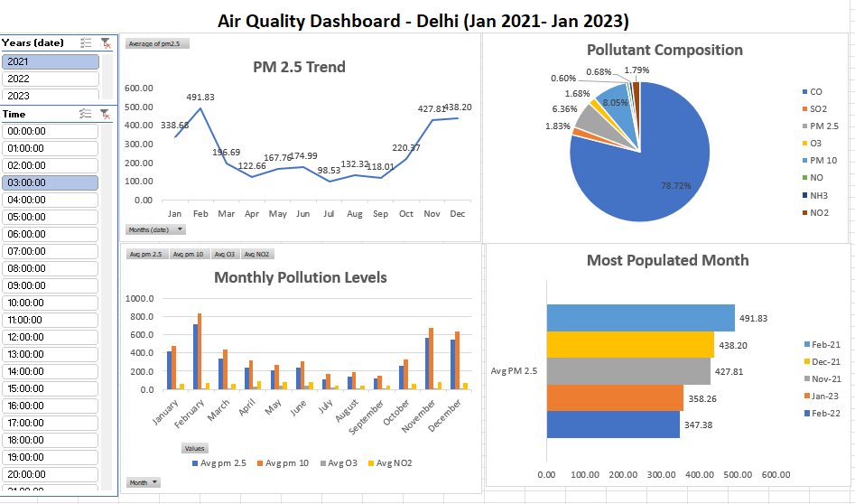

Key Findings (Insights)
Based on the dashboard visualizations, the following key findings were derived:
- Dominant Pollutant is PM 2.5: PM 2.5 accounts for a staggering 78.72% of the total measured pollutant mass. This confirms the hypothesis that it is the primary driver of air quality issues in Delhi. The next highest is PM 10 at only 8.05%.
- Clear Seasonal Pattern: The PM 2.5 Trend line graph shows a consistent and severe spike in pollution levels towards the end of the year, peaking in November and December for both 2021 and 2022. Pollution levels are lowest in the monsoon/summer months (June - August).
- Most Polluted Months are Winter Months: The "Most Polluted Month" chart confirms the worst pollution occurs during the winter-stubble burning period:
  - Feb-21 (491.83)
  - Dec-21 (438.20)
  - Nov-21 (427.81)
- Deterioration in Late 2022: The 'PM 2.5 Trend' indicates the highest peak of the analyzed period occurred in December 2022 (438.20), showing that the severity of the winter pollution issue has persisted.
- Morning Rush Hour Peak: The overall PM 2.5 concentration starts high in the early morning, slightly dips, and then shows a pronounced increase around 03:00-04:00 (3 AM - 4 AM).
- Severe Evening Peak: The pollution is worst during the evening hours. PM 2.5 and PM 10 levels rise sharply from 15:00 (3 PM) and peak significantly between 17:00 (5 PM) and 19:00 (7 PM), coinciding with peak traffic and atmospheric cooling (inversion layer formation).
- PM 10 levels consistently reach their highest point around 17:00 (5 PM).
- PM 10 is Consistently Higher: Across all hours of the day, the average concentration of PM 10 is higher than PM 2.5 (as expected, since PM 10 includes PM 2.5). Both pollutants follow a very similar pattern, peaking sharply in the late afternoon.
- NO2 Pattern Differs: Nitrogen Dioxide (NO2), primarily associated with traffic emissions, follows the same general evening spike but at much lower concentrations compared to particulate matter.

